Lab Exercise -5:
Singly Circular and Doubly Circular Linked Lists & Applications of various Linked Lists

By the end of this lab, students will be able to implement all fundamental operations on Singly Circular and Doubly Circular Linked Lists in C/C++ & also some applications of various types of Linked Lists.

A. Singly Circular and Doubly Circular Linked Lists

1. Implement a Menu Driven Singly Circular Linked List in C and C++ with all essential operations on it.
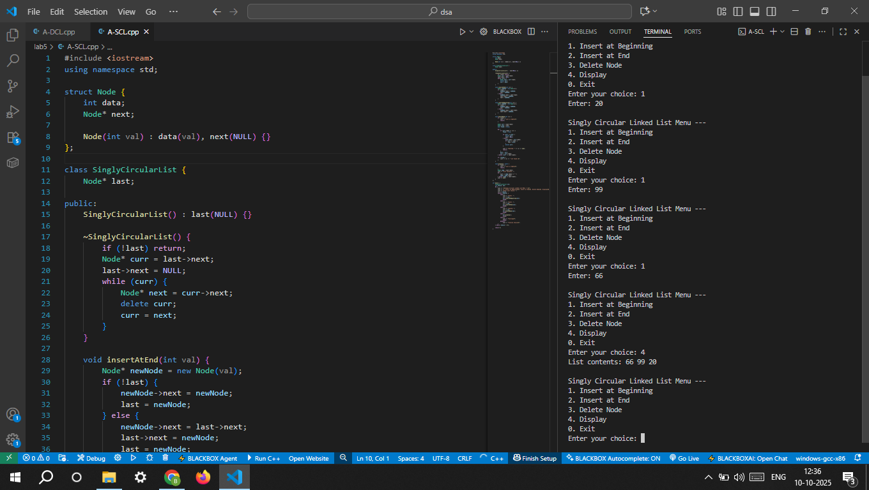
2. Implement a Menu Driven Doubly Circular Linked List in C and C++ with all essential operations on it. 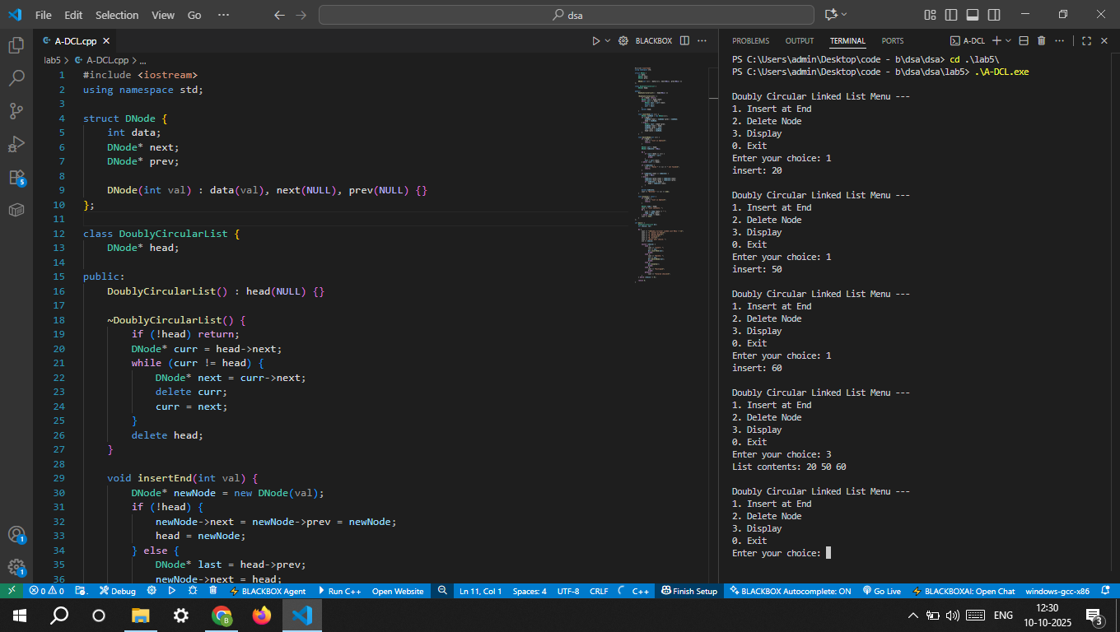

B. Applications of various Linked Lists

1. Polynomial Representation and Evaluation in C/C++ Use a Singly Linked List to represent and perform operations on polynomials.
1. Implement functions to create polynomials and evaluate the value of a polynomial at the user's value.
2. Implement a function to add two polynomials

2. Music Playlist in C/C++ Use a Doubly Linked List to implement a music playlist with the following features:
1. Add a song to the playlist
2. Remove a song from the playlist
3. Play the next song 4. Play the previous song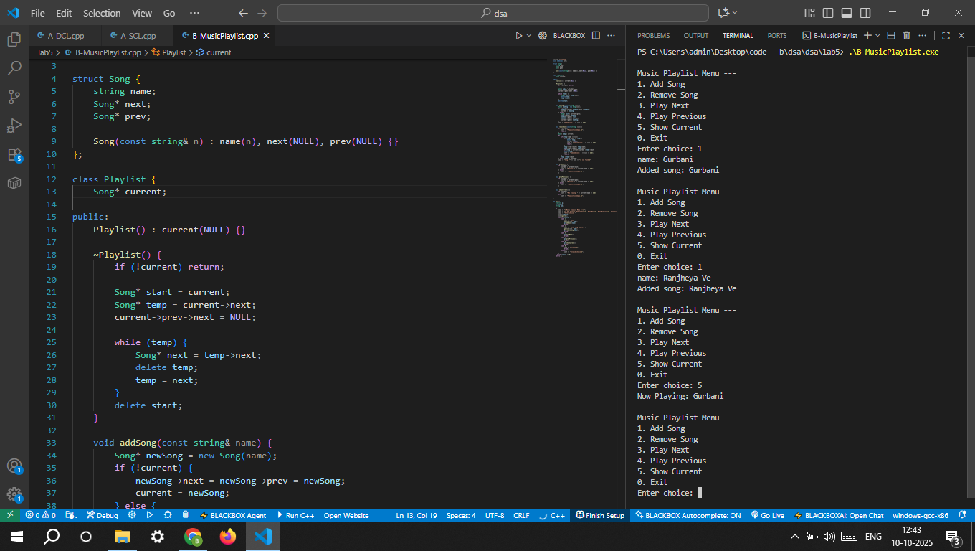

3.Round Robin Scheduling in C/C++ Use a Circular Linked List to implement a simple Round Robin scheduling algorithm:
1. Add processes to the list
2. Execute each process for a given time quantum
3. Move the executed process to the end of the list 4. Remove completed processes

